Q. Write a program in python to demonstrate Newton raphson method.

Aim: To write a program in python to demonstrate Newton Raphson method.

Program:
def f(x):
return x**3 - x - 2

def df(x):
return 3*x**2 - 1
x0 = 1.5
e = 0.0001
step = 1
print("------------------------------------------------------------")
print(" NEWTON–RAPHSON METHOD")
print("------------------------------------------------------------")
print(" Step\t x0\t\t f(x0)\t f'(x0)\t x1")
print("------------------------------------------------------------")
while True:
f0 = f(x0)
df0 = df(x0)
x1 = x0 - (f0 / df0)
print(f" {step:<5d}\t {x0:<10.6f}\t {f0:<10.6f}\t {df0:<10.6f}\t {x1:<10.6f}")
if abs(x1 - x0) < e:
break
x0 = x1
step += 1
print("------------------------------------------------------------")
print(f" Root of the equation is approximately : {x1:.6f}")
print(f" Rounded to 4 decimal places : {round(x1,4)}")
print("------------------------------------------------------------")

Output:
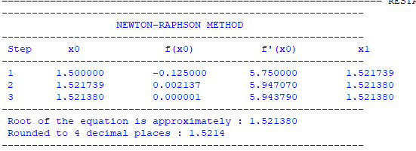

Conclusion: The above program has been executed successfully.

